

**School of Engineering and Technology**

**Internet of Things**

*(Practical File)*

**18BCS-0IT32L**

***Submitted To:***

***Submitted By:***

Name: Anubhav Sinha

Roll Number: 170BTCCSE004

Branch: Computer Science and Engg.

Year/Sem: 3rd Year – 6th Semester

Faculty: Mr. Antim Dev Mishra

Experiment 1

**Aim:** Write a program to test active and passive sensors

**Apparatus:**

* Arduino UNO
* Motion Sensor (Active Sensor)
* Ultrasonic Sensor (Passive Sensor)

**Theory:**

**Motion Sensor (Active Sensor)**

A motion detector is a device that detects moving objects, particularly people. Such a device is often integrated as a component of a system that automatically performs a task or alerts a user of motion in an area. They form a vital component of security, automated lighting control, home control, energy efficiency, and other useful systems

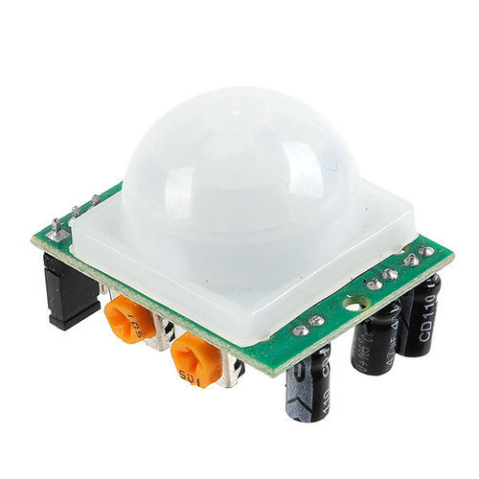

Passive infrared (PIR) sensors are sensitive to a person's skin temperature through emitted black-body radiation at mid-infrared wavelengths, in contrast to background objects at room temperature. No energy is emitted from the sensor, thus the name passive infrared. This distinguishes it from the electric eye for instance (not usually considered a motion detector), in which the crossing of a person or vehicle interrupts a visible or infrared beam. These devices can detect objects, people, or animals by picking up one's infrared radiation.

**Arduino UNO**

The Arduino Uno is a microcontroller board based on the ATmega328. It has 14 digital input/output pins (of which six can be used as PWM outputs), six analog inputs, a 16 MHz crystal oscillator, a USB connection, a power jack, an ICSP header, and a reset button. It contains everything needed to support the microcontroller; simply connect it to a computer with a USB cable or power it with an AC-to-DC adapter or battery to get started.

The Arduino Uno differs from all preceding boards because it does not use the FTDI USB-to-serial driver chip. Instead, it features the ATmega8U2 programmed as a USB-to-serial converter. Revision 2 of the Arduino Uno board has a resistor pulling the 8U2 HWB line to ground, making it easier to put into DFU mode.

|  |  |
| --- | --- |
| **Features** |  |
| * 14 digital I/O pins (six of which provide PWM output) * 3.3 V supply generated by an on-board regulator * Six analog input pins * 32 KB of flash memory | * Can supply 40 mA of DC current per pin * 16 MHz clock speed * Code example from Arduino website to help get started |

**Ultrasonic Sensor (Passive Sensor)**

Ultrasonic sensors work by emitting sound waves at a frequency too high for humans to hear. They then wait for the sound to be reflected back, calculating distance based on the time required. This is similar to how radar measures the time it takes a radio wave to return after hitting an object.

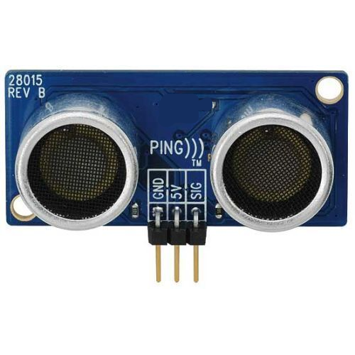

**Interfacing Active Sensor:**

**Circuit:**

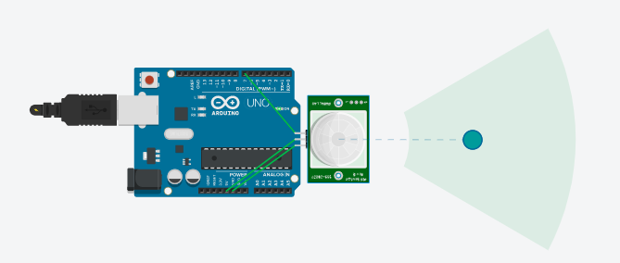

**Code:**

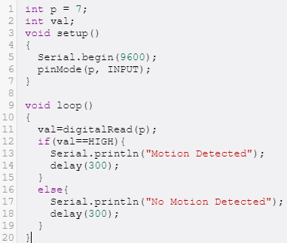

**Result:**

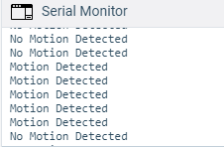

**Interfacing Passive Sensor:**

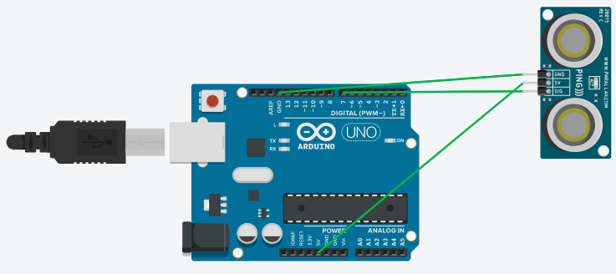

**Code:**

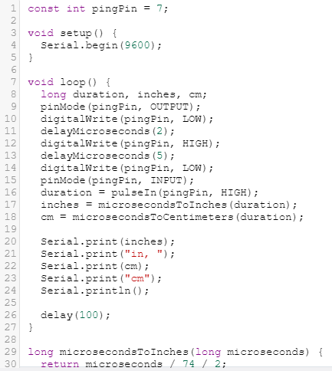



**Output:**

